
HAMILTON
Essex County
NARRATIVE
GEOGRAPHY
GOVERNMENT
DEMOGRAPHICS
HOUSING_CHARACTERISTICS
TRANSPORTATION
CULTURE AND RECREATION
MISCELLANEOUS

NARRATIVE

Narrative
The Town of Hamilton is located in the eastern central portion of Essex
County, in Eastern Massachusetts. Many of the approximately 7000 residents
of the town commute to Boston, 24 miles away, while others are employed in
area communities. Currently the town has no manufacturing industry and no
industrially-zoned land. Hamilton's identity as a predominantly suburban
bedroom community is assured.
Hamilton has special appeal as a residential community. Its North Shore
location provides easy access to the Atlantic seashore with its preserves,
beaches and boating. The town's surroundings typify rural New England and
include many handsome historic houses. Large areas of open and agricultural
land encompassing the Audubon preserve, Bradley Palmer State Park, Myopia
Hunt Club and several large estates and farms create a pastoral
environment. The visitor to the town is quite likely to share the back
roads with horseback riders. The town also has Chebacco Lake within its
boundaries, which provides for additional recreation activities.
Situated on a beautiful hill in the town is the Gordon-Conwell Theological
Seminary, and nearby is Gordon College. Hamilton shares an excellent
regional school system with the Town of Wenham and its educational
resources are an attraction for the town.
(Narrative supplied by community)

GEOGRAPHY

Location
Northeastern Massachusetts, bordered by Ipswich on the north, Essex on the east,
Manchester on the southeast, Wenham on the south, and Topsfield on the west.
Hamilton is about 15 miles south of Newburyport, 21 miles southeast of Lawrence,
24 miles north of Boston, and 245 miles from New York City.
Total Area: 14.94 sq. miles
Land Area: 14.60 sq. miles
Population: 7,280
Density: 499 per sq. mile
Climate
(National Climatic Data Center)
(Middleton Station)
Normal temperature in January.....25.8°F
Normal temperature in July........71.6°F
Normal annual precipitation.......43.6"
U.S.G.S. Topographical Plates
Marblehead North, Ispwich, Georgetown, Salem
Regional Planning Agency
Metropolitan Area Planning Council
Metropolitan Statistical Area
(1993 Definition)
Boston

GOVERNMENT

Municipal Offices
Main Number: (978) 468-5570
Telephone Numbers for Public Information

Form of Government
Board of Selectmen
Administrative Assistant
Open Town Meeting
Year Incorporated
As a town: 1793
Registered Voters (Secretary of State 1994)

Number %
Total Registered 4,373

Democrats 625 14.3 %
Republicans 1,089 24.9 %
Other parties 0 0.0 %
Unenrolled Voters 2,659 60.8 %
Legislators
Senators and Representatives by City and Town

DEMOGRAPHICS

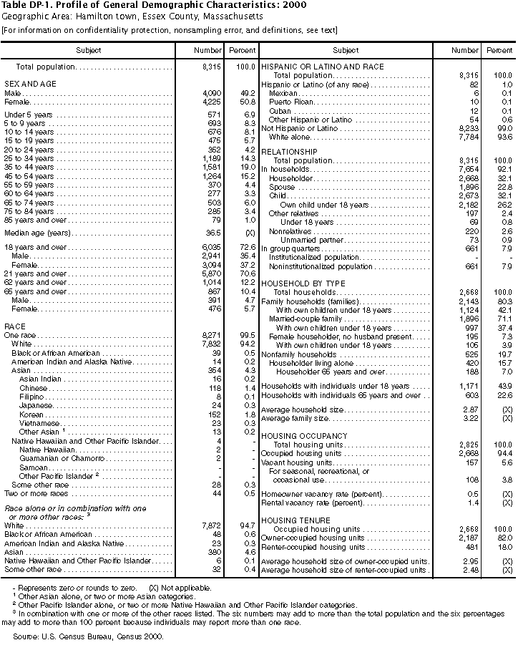

HOUSING CHARACTERISTICS

Home Sales (Banker & Tradesman)-
Town Stats - Free market Statistics
Subsidized Housing Units (DHCD 1998)
DHCD Subsidized Housing Inventory
Subsidized Housing Units: The number of housing units which count toward the municipality's 10% goal for low- and moderate-income housing. It includes both subsidized affordable units and market rate units in certain eligible subsidized developments.
Public Housing Units (DHCD 1999)

Conventional State: 63
Conventional Federal: 0
Rental Assistance(DHCD 1999)
State (MRVP: 0
Federal (Section 8): 0

TRANSPORTATION

TRANSPORTATION AND ACCESS
Hamilton is situated in the Greater Boston Area, which has excellent rail,
air, and highway facilities. State Route 128 and Interstate Route 495
divide the region into inner and outer zones, which are connected by
numerous "spokes" providing direct access to the airport, port, and
intermodal facilities of Boston.

Major Highways
Principal highways are State Route 1A, which runs N-S to the Massachusetts
border, and State Route 22. State Route 128, the inner belt around Boston,
passes just south of town in Manchester.

Rail
Commuter rail service to North Station, Boston, is available on the Ipswich
line from Hamilton and North Beverly, and on the Rockport line from
Manchester. Travel time from Hamilton/Wenham Station: 46-48 min.; free
parking lot.

Bus
Hamilton is a member of the Massachusetts Bay Transportation Authority
(MBTA).

Other
The Beverly Municipal Airport, a Reliever (RL) facility in neighboring
Beverly, has 3 asphalt runways 3,500'; 4,634'; and 5,001' long. Instrument
approaches available: Non-precision.

CULTURE AND RECREATION

LIBRARIES
Board of Library Commissioners On-line Library Catalog
MUSEUMS
(American Association of Museums)
None
RECREATION
Telephone Numbers for Public Information
Recreational Facilities(Recreational sites and activities)
Department of Environmental Management Recreation Section

MISCELLANEOUS

HEALTH FACILITIES
(Dept. of Public Health 1992)
Hospitals
None
Long Term Care
None
Hospices
None
Rest Homes
None
UTILITIES
Telephone Numbers for Public Utilities
At A Glance Report - Massachusetts Department of Revenue - Division of Local Services
FY99 Estimated Receipts

ACKNOWLEDGEMENT

The Department of Housing and Community Development would like to thank the many government agencies noted as having provided information for the community profiles. In addition to these agencies, the Regional Transit Authorities assisted with the transportation component of the profiles. We gratefully acknowledge the assistance of many city and town officials, which enabled us to include information obtainable only at the local level. DHCD would also like to thank the following individuals for providing special help: Leslie A. Kirwan, Deputy Commissioner, Division of Local Services, Department of Revenue; Richard Shibley, Deputy Secretary of State; Bob Beattie of the Department of Public Health; Charles W. Clifford from the Martha's Vineyard Commission; Dennis Coffey of the Executive Office of Transportation and Construction; Donna Fletcher and Christian Jacqz of the Executive Office of Environmental Affairs; James Griffin from the MBTA; Karen Loh from Banker & Tradesman; Todd Maio from the Department of Welfare; Geoffrey Morton from the Election Division of the Secretary of State's Office; Stephen R. Muench of the Massachusetts Aeronautics Commission; Rol Murrow of the Aircraft Owners and Pilots Association; Mary Ann Neary and Emmanuelle Fletcher, reference librarians at the State House Library; Jeff Nellhaus from the Department of Education; and George Sanborn, reference librarian at the State Transportation Library.
NOTE: The COMMUNITY PROFILE draws information from a diversity of sources. The main source of information is listed under each section. In some instances comments submitted by the municipality were incorporated to correct and/or enhance the information obtained from the main source. However, no changes were made to those data bases which must be consistent throughout the state. DHCD has made efforts to ensure the accuracy of all data in the COMMUNITY PROFILES, but cannot take responsibility for any consequences arising from the use of the information contained in this document.

