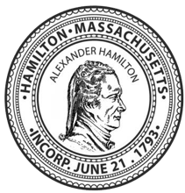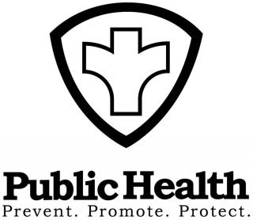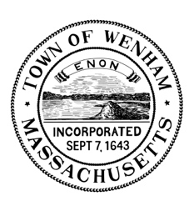

Announcement of Changes to Hamilton and Wenham Public Health Clinics

The Health Departments of Hamilton and Wenham, in cooperation with the Eastern Essex Regional Public Health Coalition (EERPHC) and Greater Cape Ann Community Coalition (GCACC), announce changes to their ongoing COVID-19 vaccination clinics.

- These weekly 4:30-6:30 clinics will now be called Public Health Clinics.
- The venues will alternate weekly, between the Hamilton and Wenham COA buildings.
  - The Hamilton COA, located at 299 Bay Road, will be hosting Public Health Clinics on the first and third Wednesday of each month.
  - The Wenham COA, located at 10 School Street in Wenham, will be hosting the Public Health Clinics on the second and fourth Wednesday of each month.
- COVID and influenza vaccines will be offered from 4:30-6:30. Sign up for COVID vaccines at capeannclinic.com. Walk-in appointments for COVID and flu vaccines are available each week.
- The EERPHC Regional Social Worker, Jessie Palm, LICSW, or the Regional Public Health Nurse, Rachel Lee, will be available for drop in questions from 4:30-5:30 each week.
- The Hamilton or Wenham or Regional Public Health Nurse will be available each week for vaccinations and for any other public health/nursing related questions.
- The second hour of each Public Health Clinic will present a
Community Health Education Program, where a health professional will present a topic of interest from 5:30-6:15 pm with a Q/A session from 6:15-6:30 pm.
  - February 15th, and Feb 22nd, Judith Ryan, RN, BSN, Hamilton’s new Public Health Nurse will be presenting on Heart Health.
  - Wednesday, March 1st and March 8th, EERPHC’s Regional Social Worker, Jessie Palm, LICSW will present on Recognizing and Managing Stress in Our Lives.

