AUTO READ - SENSUS

Quarterly Billing Instructions
7/13/15

Double click the ICON “AUTO READ” on your desktop

It will bring up the old database.

You 1st need to clear the information from the AUTOREAD DATABASE from the last quarter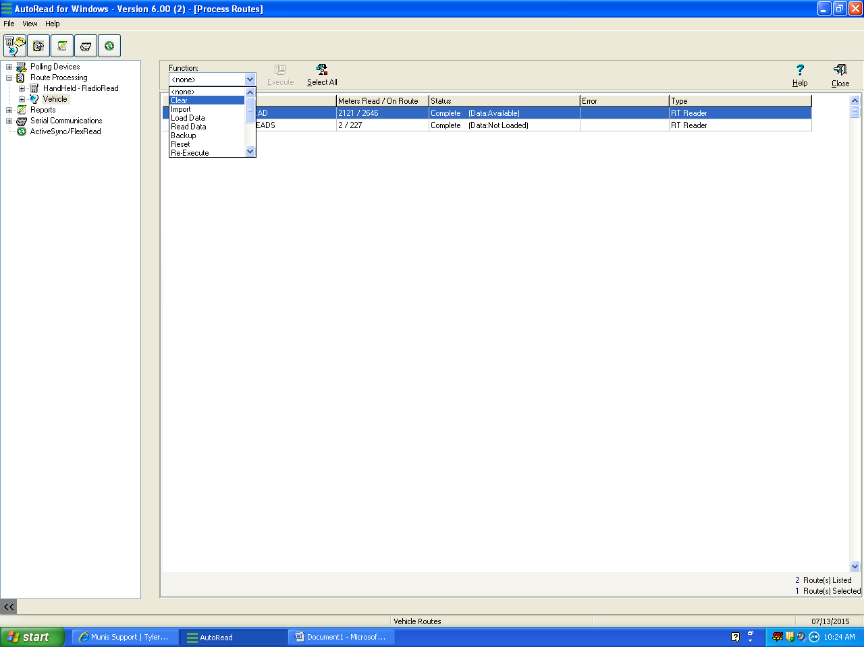
Choose “CLEAR” from the drop down
Click “EXECUTE” Button

Choose “IMPORT” from the drop down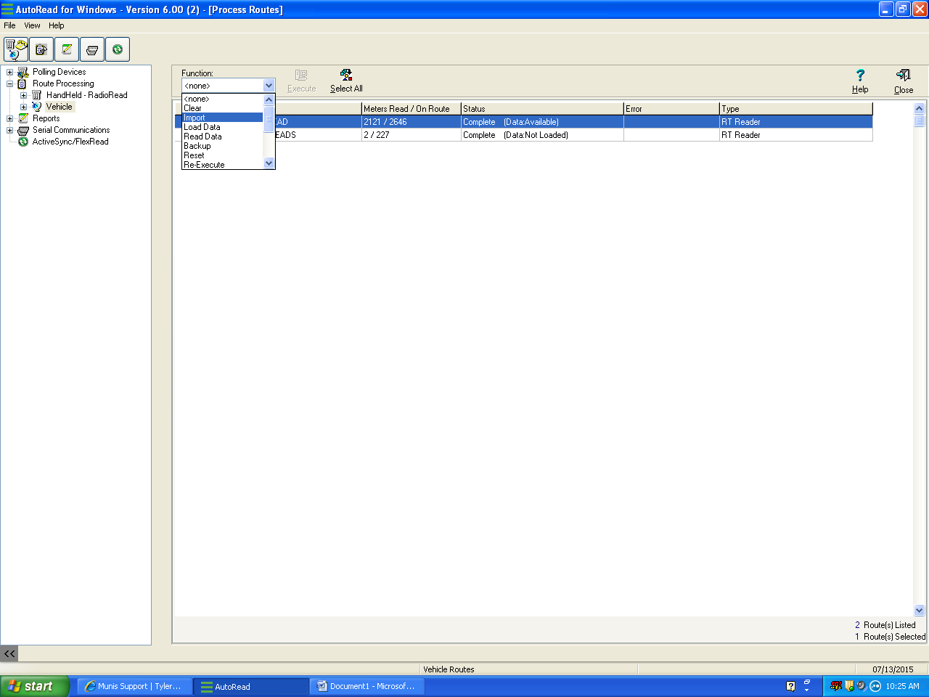 Click “EXECUTE” Button

Click “VXU-UNREADS” on the left. 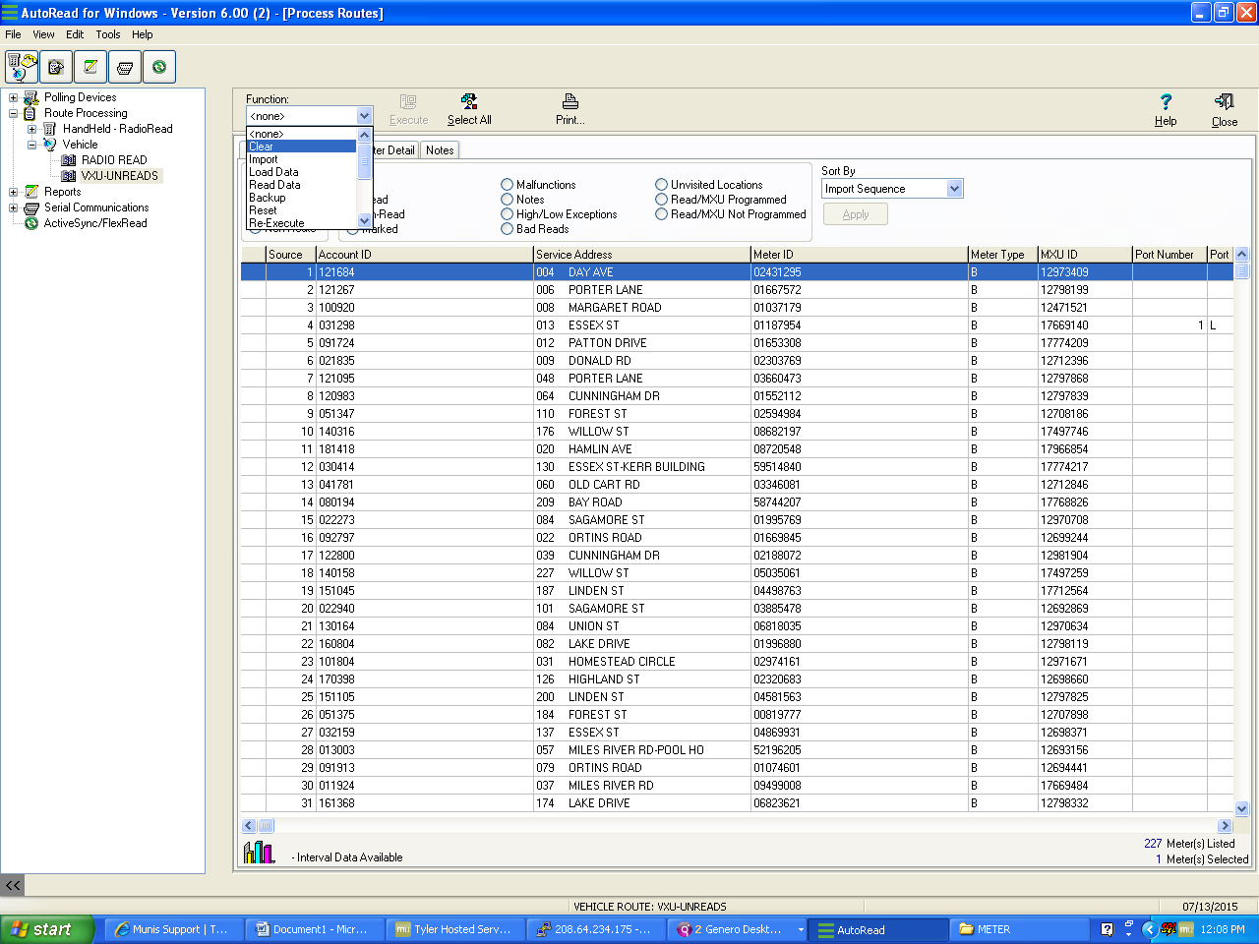

Click “CLEAR” Click “EXECUTE”
Make sure you clear the old file VXU-UNREADS before loading in the new data from the guys out reading the data
Cl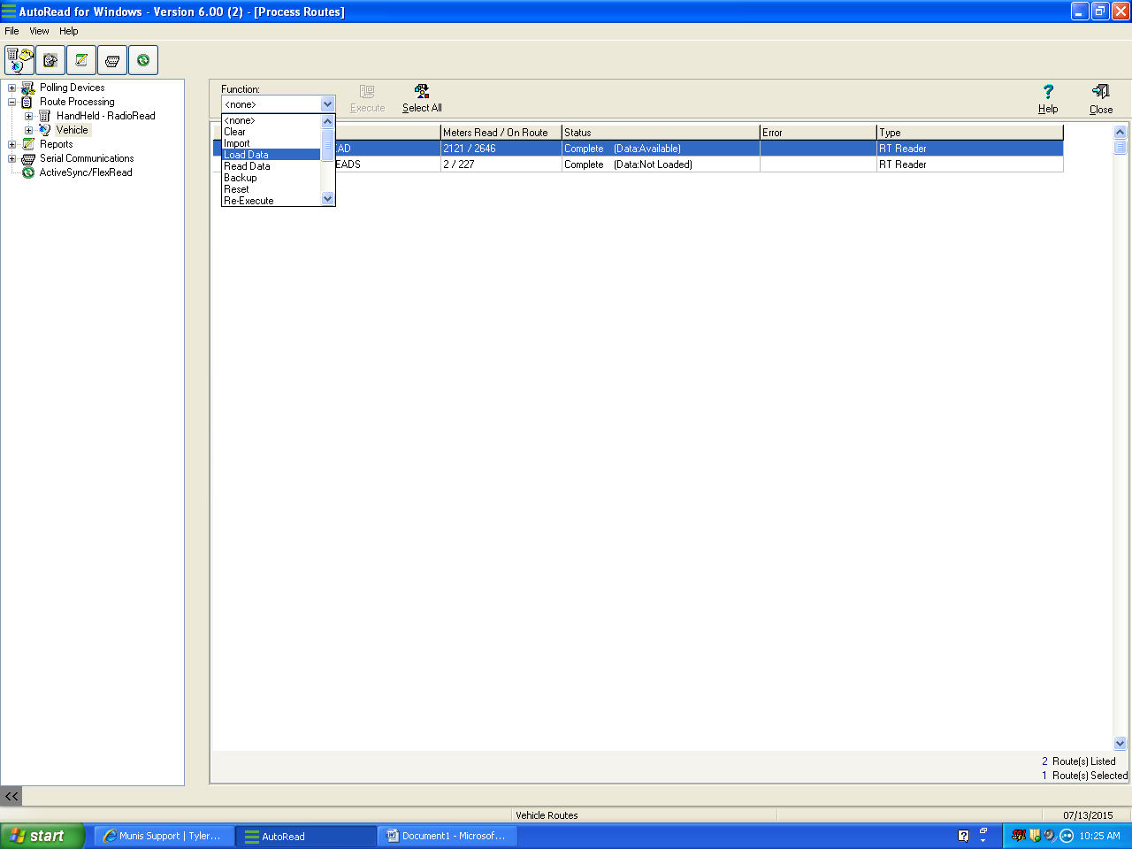

READ METERS

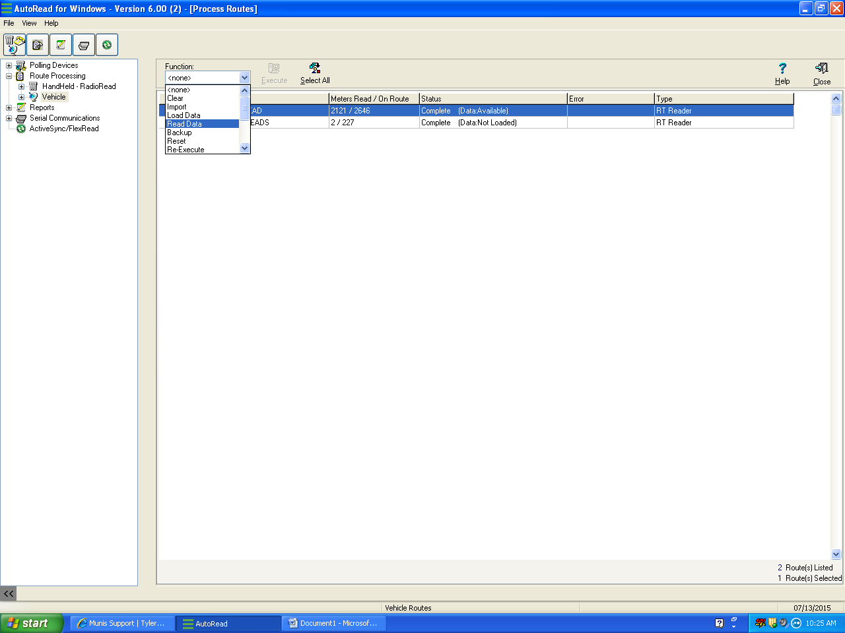

Make sure you clear the old file VXU-UNREADS before loading in the new data from the guys out reading the data

