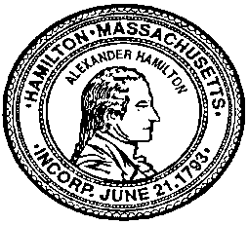

Town of Hamilton Planning Board
PO Box 429, 577 Bay Road

Hamilton, MA 01936
978-626-5248

Notice of Planning Board SITE VISIT

The Hamilton Planning Board will gather for a site visit on June 28, 2017, 2016 at 5:00PM at the Pingree Campus, 537 Highland Street, Hamilton, MA 01982 in accordance with MGL Chapter 40A, Section 10, and the Hamilton Zoning By-law relative to: A Site Plan Review Application for a project to expand athletic facilities at the subject property. The Pingree School, Inc., is the applicant and proposes to construct a synthetic turf field within an oval track in addition to a new girl’s softball field. Lighting is part of the proposed project. The project is within the R-A zoning district. NO ON-SITE DELIBERATION BY THE BOARD WILL OCCUR AS PART OF THE SITE VISIT.

Applications and plans are on file and available for review at the Hamilton Planning Department during regular town hall business hours.

Patrick Reffett
Director of Planning & Inspections

