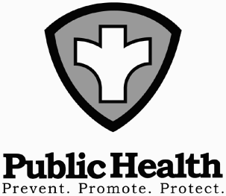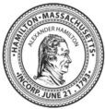 **Town of hamilton**

Board of Health **–** *Dennis Palazzo, Director*

*299 Bay Rd, Hamilton 01936*

*978-626-5245*

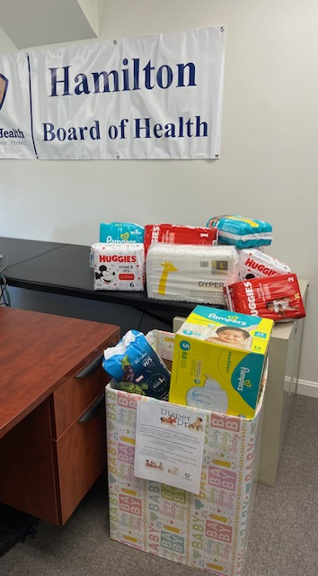**Hamilton Health Department Thanks Residents Who Donated During April Diaper Drive**

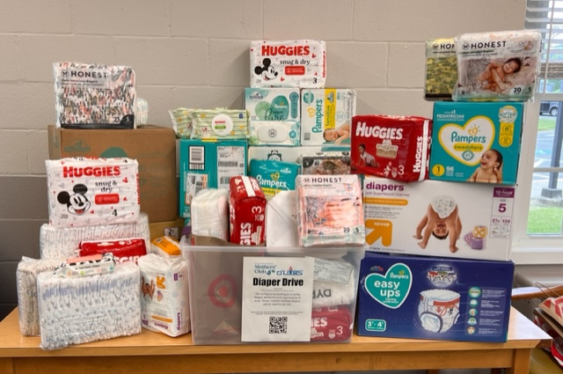

On behalf of the Hamilton Health Department, thank you to all who provided diaper and wipes donations during the Town’s Diaper Drive. Over 1200 diapers and just under 500 wipes were collected along with a check donation. All diapers, wipes and checks donated have been given to Accord Food Pantry, benefitting families in need.

These donations demonstrate the compassion and willingness of the community to work together and improve the lives of our children and families. A special thank you goes to all those who collaborated in collecting, especially the H/W Mother’s Club, and providing support by raising public awareness around the impact of the unmet need for diapers in Hamilton and throughout the nation.

For further information, please contact Public Health Nurse, Judith Ryan, at 978-626-2150