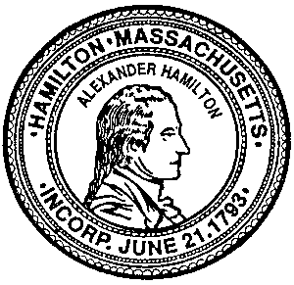
HAMILTON BOARD OF HEALTH
577 Bay Road, P.O. Box 429
Hamilton, MA 01936
Tel.:978-468-5245
Fax: 978-468-5582

APPLICATION for RETAIL SALES PERMIT
TOBACCO and NICOTINE DELIVERY PRODUCTS

Fee: $200.00, payable to: Town of Hamilton.
- THIS APPLICATION IS FOR: o NEW PERMIT o RENEWAL
- NAME OF RETAIL ESTABLISHMENT (as it appears on your Town of Hamilton Business License):
___________________________________________________________________________
- ALTERNATE NAME OF ESTABLISHMENT (DBA) (other name under which the business operates):
___________________________________________________________________________
- LOCATION OF ESTABLISHMENT: MAILING ADDRESS (if different from location):
___________________________________ _____________________________________
Address Line 1 Address Line 1
__________________________________ _____________________________________
Address Line 2 Address Line 2
__________________________________ _____________________________________
City, State, Zip Code City, State, Zip Code

- HOURS OF OPERATION: _____ to _____ DAYS OF OPERATION: ________ thru ________
- TYPE OF BUSINESS OWNERSHIP: o Chain Owned o Independently Owned
- BUSINESS CATEGORY: o Grocery Store o Convenience Store
o Other (describe) ________________________________________________________
- NAME OF ESTABLISHMENT OWNER: __________________________________________
- HOME PHONE: ________________________ BUSINESS PHONE: ____________________
- EMAIL ADDRESS: ___________________________________________________________
- NAME OF MANAGER (if different from Owner):_______________________________________
- MA Department Of Revenue CIGARETTE RETAILER’S LICENSE NUMBER:_____________
(A copy of this license, or other proof of payment, MUST BE ATTACHED to this Application)
Pursuant to M.G.L. Chapter 62 C. Section 49A, I certify under the penalties of perjury that, to my best knowledge and belief, I have filed all state tax returns and paid all state taxes required under the law.

I declare that I have read the Hamilton Board of Health Regulations restricting the sale of tobacco products and nicotine delivery products (adopted June 25, 2014 and revised June 29, 2016) and prohibiting smoking in workplaces and public places (adopted June 25, 2014). I accept responsibility for instructing any and all employees who will be responsible for tobacco sales regarding these regulations.

________________________________ _________________________________ ________
Owner’s Social Security # or Federal ID # Signature of Applicant or Corporate Officer Date

