3 DIY Holiday Decorations for Your Home

The holidays are right around the corner! What better way to save money while spending quality time with your families than crafting your own holiday decorations! Here are 5 cheap and simple ideas to make your home extra cozy this season.

1. Frosty the Fridge
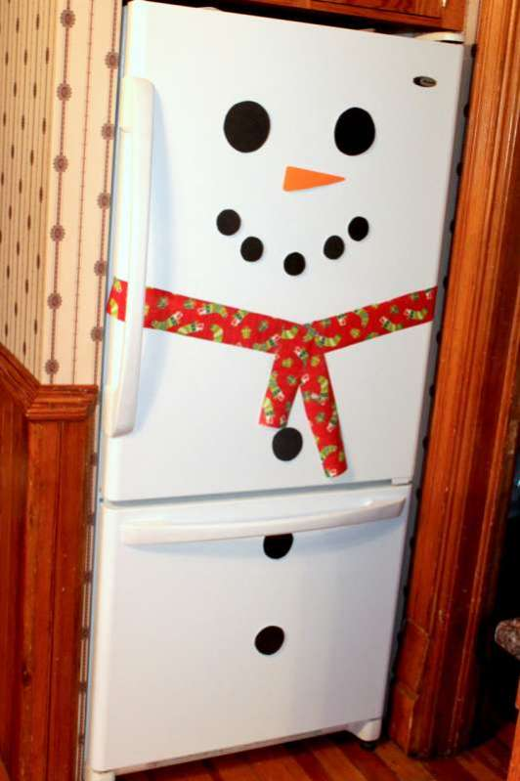
source: http://handsonaswegrow.com/activity-snowman-fridge/

What you will need:
1 black foam sheet or construction paper
1 orange foam sheet or construction paper
Wrapping paper
Tape or adhesive magnets

Directions:
- Cut the black sheet so you have a total of 2 large circles (eyes), 3 medium circles (buttons) and 5 small circles (mouth).
- Cut a large triangle from the orange sheet for the nose.
- Take any scrap wrapping paper to form into the snowman’s scarf. Cut into wide strips and tape in place.
- Use tape or adhesive magnets to secure all of the parts into place on your refrigerator!
- (optional) if you have a hat, place on top of your refrigerator and watch Frosty come to life!
Don’t think your fridge will work for this project? Try on a door instead!

2. Holiday Card Wreath
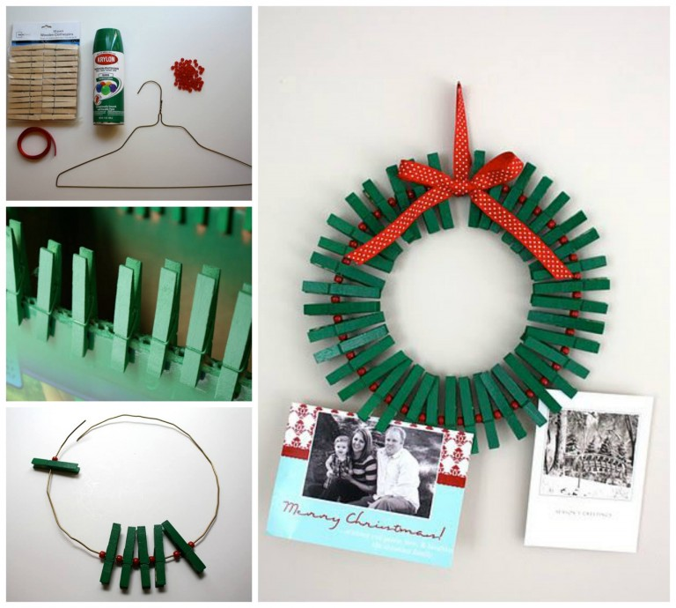
Source : http://www.gwennypenny.com/2010/12/haul-out-holly-day-8-with-craftiness-is.html

What you will need:
50 pack of Clothes Pins
1 yard of ribbon
Wire clothes hanger
Green spray paint
Pony beads or other decorations
Wire cutter
Glue gun

Directions:
- Place your clothes pins on something that will prop them up, such as a box
- Spay 3-4 coats of the green paint covering all areas and let dry.
- Cut the hook from the wire hanger and shape into a circle
- Alternate sliding the clothes pins, beads, and any other decorations you may have into the wire until the wire is just about full. (leave space for the wires to overlap)
- Hot glue the wires together
- Cut a piece of ribbon to tie around the wire, then trim the ends and glue to the wire
- Using the rest of the ribbon, tie a bow and glue to the top of the wire
- Hang on the wall and pin your holiday cards!

3. Candy Cane Vase
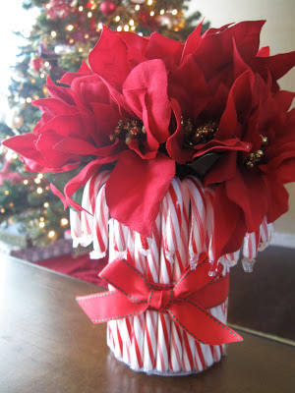

Source: http://www.livingwellspendingless.com/2010/12/17/christmas-party-planning-candy-cane-arrangement/

What you will need:
1 box of candy canes
Empty can
Ribbon
Artificial (or real) flowers
Hot glue gun

Directions:
- Hot glue the back of the candy canes all around the empty can.
- Cut the ribbon and glue around the candy canes.
- Create a bow and glue it to the front.
- Find artificial poinsettias or other flowers from unused decorations and place in the vase!

