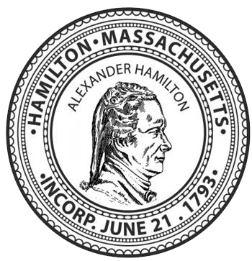
TOWN OF HAMILTON
BOARD OF HEALTH MEETING MINUTES

Town Hall - 577 Bay Road - Memorial Room
Wednesday June 23, 2021
5:30 pm

5:35 pm Meeting called to Order. Present are Chair David Smith, Members Giselle Perez and Christopher Small, Health Agent Leslie Whelan and Public Health Nurse Rachel Lee.
Motion by David Smith, seconded by Christopher Small to approve the Minutes of 5/26/21. All in favor.
Covid Vaccinations Update: town-wide percentages, future clinics, and reaching the hard-to-reach. - Rachel Lee provided updates on the recent clinics, future clinics, and plans to increase outreach to trades people who may not speak English as a first language, and to the 20-29 year group. Plans are underway to hold a clinic at the Seminary, and bi-weekly at the Public Safety Building.
Chebacco Lake Watershed Association and Harmful Algal Blooms - David Smith has reached out to Sue McLaughlin, President. After the meeting had adjourned David Lash, past President arrived and introductions and informal discussion took place.
Mosquito Control Update - A reminder to residents to submit an annual exclusion form was placed on the town website and sent out via social media. Discussion of Board of Health’s position on adulticide spray. The policy statement at the end of the TIps to Protect from Mosquito bites document on our webpage was amended to allow for the possibility for adulticide spray under certain circumstances such as human case(s) of EEE. Motion to amend last sentence to: “There are no plans to spray at this time or in the foreseeable future unless circumstances change (e.g. human cases of EEE).” Motion made by David Smith, seconded by Giselle Perez. All in favor
Update on status of the new Health Department - Part time Admin position has been posted. Health Director position, and 2 regional grant positions have yet to be posted.
Giselle Perez motioned to adjourn, Christopher Small seconded. All in favor. Adjournment at 6:20 pm

