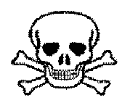
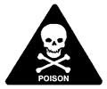
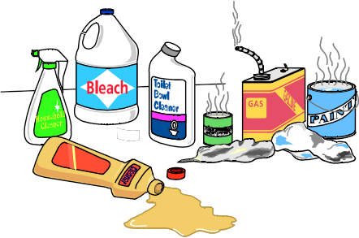
Household Hazardous Waste Collection Day
Do Evil Spirits Lurk in Your Home?
Clean the skeletons out of your closets, basement, and garage.
Open to Hamilton and Wenham residents only. Checks Only Payable to: Town of Hamilton

Date: Saturday, September 22, 2018 Time: 9:00 AM - NOON
Place: Hamilton DPW Yard, 577 Bay Road Info: Hamilton Town Hall 978-626-5227

WHAT DO I BRING??
From the W orkbench: From the Garage: From the House:
✓ | Oil Based Paints | ✓ | Fuels/Gasoline/ Kerosene | ✓ | Rubber Cement, Airplane Glue
✓ | Stains & Varnishes | ✓ | Engine Degreaser | ✓ | Fiberglass Resins
✓ | Wood Preservatives | ✓ | Brake Fluid/Carburetor Cleaner | ✓ | Aerosol Cans
✓ | Paint Strippers/Thinners | ✓ | Transmission Fluid | ✓ | Photo Chemicals
✓ | Solvent Adhesives | ✓ | Car Wax, Polishes | ✓ | Furniture Polish
✓ | Lighter Fluid | ✓  ✓ | Driveway Sealer  Antifreeze | ✓  ✓ | Floor & Metal Polish  Oven Cleaner
From the Yard: ✓ Roofing Tar ✓ Drain & Toilet Cleaner
✓ | Weed Killer | ✓ | Swimming Pool Chemicals | ✓ | Spot Remover
✓ | Chemical Fertilizers | ✓ | Motor Oil | ✓ | Rug & Upholstery Cleaner
✓  ✓  ✓ | Flea Control Products  Moth Balls  Poisons, Insecticides, Fungicides |  |  | ✓  ✓ | Hobby Supplies, Artist Supplies  Chemistry Sets
Fees:

$60.00 for up to 25 gallons or 25 pounds for HW
$36.00 for up to 10 gallons or 10 pounds for HW
$30.00 for up to 3 gallons or 3 pounds for HW

*Latex paint will NOT be accepted (see below)

How Can I Safely Transport
What NOT to Bring?????? These Hazardous Materials???

Ø Ø | Empty Containers/Trash  PRESCRIPTION DRUGS OR MEDICATIONS  |  Leave materials in original containers.
Ø  Ø Ø Ø  Ø Ø Ø  Ø | Commercial or Industrial Waste  Radioactive Waste, Smoke Detectors   Infectious & Biological Wastes Ammunition, Fireworks, Explosives  Fire Extinguishers Syringes    Organic Peroxides  Propane tanks (contact retail distributor for disposal)  Latex Paint  hhssssssddid | ⬥ Tighten Caps and lids.   Sort and pack separately: oil paint, pesticides, and household cleaners.   Pack containers in sturdy upright boxes and  pad with newspaper.   NEVER MIX CHEMICALS.   NEVER SMOKE while handling hazardous material

This collection is operated by: Clean Harbors Environmental Services (800) 263-1304

*Latex Paint is NOT hazardous - Please solidify by removing lid to allow paint to dry out and dispose of the hardened paint with your regular trash NOT RECYCABLES

The Hamilton Police Department holds an annual National Take Back Prescription Day. Find details at www.hamiltonma.gov

