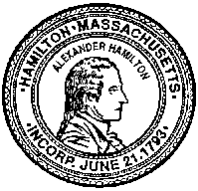
TOWN OF HAMILTON
Carin A. Kale, Town Clerk
978-468-5570 x 3 townclerk@hamiltonma.gov

SPECIAL TOWN MEETING
OCTOBER 23, 2021
RESULTS

Called to order at 9:10 a.m.; 111 voters present

2021/10 2-1: Prior Year Bills – Motion passes 88 yes, 3 no

2021/10 2-2: Amendment to Budget – Motion passes 99 yes, 1 no

2021/10 2-3: Election Staffing – Motion passes 95 yes, 8 no

2021/10 3-1: Amendment to General Bylaws – BOS Name Change – Motion passes 81 yes, 23 no

2021/10 3-2: Amendment to Zoning Bylaw – BOS Name Change – Motion passes 86 yes, 21 no

2021/10 3-3: Special Act to Refund Real Estate Taxes 550 Highland Street – Motion passes 87 yes, 20 no

2021/10 3-4: Authorization to Convey Easement to NGrid – Motion passes 102 yes, 4 no

Dissolved at 9:50

