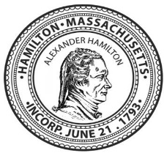

**TOWN OF HAMILTON**

**BOARD OF HEALTH (BOH) MEETING MINUTES**

MEETING DATE: MONDAY JUNE 27, 2022, 5:00 pm

Memorial Room, Hamilton Town Hall

**Hamilton Board Members Present** – David Smith (Chair), Christopher Small, Dr. Giselle Perez

**Others Present** – Peter Mirandi (Consultant to the Health Director), Jean Ramsey MD MPH (Boston University)

**Call to order** – The meeting was called to order at 5:05 p.m. by David Smith.

There was discussion of a request to support state legislation that would require monitoring of CO2 levels in indoor public spaces. It was noted that CO2 monitoring is a measure of the degree to which air is circulating and provides a metric of the health of indoor spaces, especially important with the concern for COVID exposure. Mr. Mirandi indicated that the correlation between indoor air quality and COVID transmission is clear. Board members discussed the importance of incorporating into the bill a requirement that measures be taken to alleviate a ventilation problem when detected through the monitoring system. A motion was made by David Smith that the Board support legislation requiring CO2 monitoring in public indoor spaces, and in addition, endorse that remedial measures be required to deal with health-based guidelines. This motion was further amended to include “including public school indoor spaces” instead of simply “public indoor spaces”. The vote on the amended motion was passed unanimously. Vote: Smith – Aye; Small – Aye; Perez – Aye.

There was consensus that the “Board of Health Policy on Public Posting of Board Announcements – Draft #1” would not be voted on at the meeting. Board members agreed to review the draft document and send revisions to David Smith. The revised draft of the document will be discussed at the next Board of Health meeting.

After discussion, it was decided not to vote on whether the Board should continue to require reporting of the addresses of positive COVID-19 cases to Hamilton Public Safety, as town health staff needed to be involved in this discussion. David Smith will reach out to them and present this agenda item again at the next BOH meeting.

No update on COVID-19 data was provided.

David Smith reported that a concern was raised by a couple of residents about the lack of town board meeting minutes. David updated the BOH about the ongoing challenges in staff availability for this task.

David Smith announced that Chris Small would be retiring from the BOH as of June 30, 2022, a position that he has held for four years. (Letter Document from David Smith to be attached to the meeting minutes). David reported that the Select Board voted unanimously in favor of Jean Ramsey filling this position on the BOH.

Chris Small made a motion to approve the May 12, 2022 minutes. This motion was seconded by David and approved unanimously by the Board. Vote: Smith – Aye; Small – Aye; Perez – Aye.

Peter Mirandi reported that a Hamilton resident had expressed concern about the development project on Essex Street. It was proposed that the resident(s) be invited to the next BOH meeting to provide information about their concerns in order to determine what issues may be reasonable for the Board to address.

Chris Small made a motion to adjourn the meeting at 6:00 pm. Motion was seconded by Dr. Giselle Perez and approved unanimously. Vote: Smith – Aye; Small – Aye; Perez – Aye.

**TOWN OF HAMILTON**

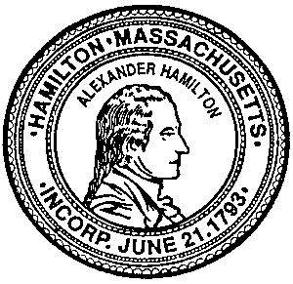

BOARD OF HEALTH

577 Bay Rd., P.O. Box 429

Hamilton, MA 01936

Tel: 978-626-5245 Fax: 978-468-5582

**June 27, 2022**

**Shawn M. Farrell, Chair, Select Board  
Joe Domelowicz, Town Manager  
Town of Hamilton  
577 Bay Road**

**Hamilton, MA 01936**

**Subject: Board of Health service of Chris Small**

**The purpose of this letter is to express to the Town my gratitude and thanks to Chris Small for his volunteer service on the Hamilton Board of Health for the past four years. Since the COVID-19 pandemic began almost 2-1/2 years ago, Chris has been invaluable to me and the Board, and to the Town. He has been the calm, steady, common-sense voice of reason in a very turbulent and controversial time for the Board. I particularly appreciate his astute contributions to the difficult decisions the Board faced and the public announcements the Board had to issue during this time.**

**The Town would be fortunate and in good hands to have Chris serve on any of the many Boards and Committees that regularly seem to have openings.**

**Thank you, Chris!**

**David B. Smith**

**Chair, Hamilton Board of Health**

**cc: Chris Small**

-