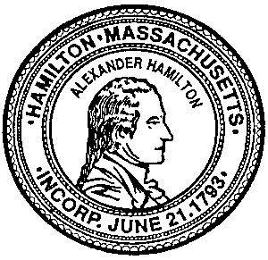
Town of Hamilton
Board of Health

Employee Agreement
(to be completed by each employee of the Establishment and kept on file)

I understand that Massachusetts General Laws now mandates fines of $1,000 for a first violation, $2,000 for a second violation and $5,000 for a third violation for violating the following policies:

- tobacco or vape sales to anyone under the age of 21;
- general vape retailers that sell vape solutions with a nicotine concentration greater than 35 milligram/milliliter;
- required signage;
- free distribution of tobacco or vape products;
- sale of single cigarettes;
- failure to check identification of any purchaser; and
- redemption of coupons for tobacco or vape products

I agree to adhere to all the federal, state and local rules and regulations pertaining to the sale of tobacco in the Town of Hamilton, MA.
In turn, management supports my judgement not to make the sale in any of the above circumstances.

__________________________ __________________________ ____________
Employee’s signature LEGIBLY PRINT employee’s name Date

__________________________ __________________________ ____________
Store Manager’s signature LEGIBLY PRINT manager’s name Date

______________________________________________________________________
Business Establishment Name

______________________________________________________________________
Business Establishment Address

